**Sequence Diagram: Event Registration**

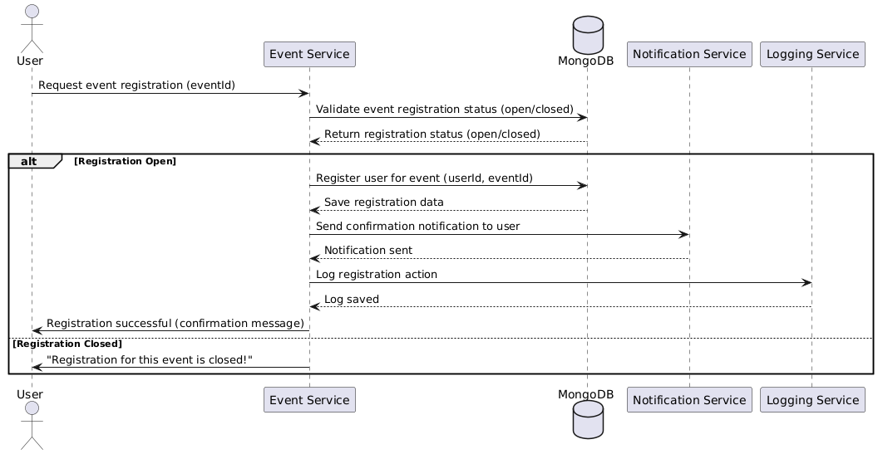

**Database:**

**Functional Requirements (FRs)**

* **FR1:** The system shall allow users to register for events.
* **FR2**: The system shall validate if event registration is open before proceeding**.**
* **FR3:** The system shall send confirmation emails after successful registration.

**Non-Functional Requirements (NFRs)**

* **NFR1:** Registration should be completed in under 2 seconds.
* **NFR2:** The system must handle at least 100,000 registrations per hour during peak load.